Final Project Proposal
Baseball Team Manager
John Colligan, CS 121

Purpose of this project –
This is for people that enjoy the game of baseball and would like to manage their own team and make their own decisions for the lineup they want to put out, the pitchers they want to pitch, and for the players they just want on their team.

How this project will work –
The user will create a team, manage the players, simulate all the games within the season, and the game will track the stats for the players.

Classes –
The first class will be the Player class. This class will store the players’ main information, like their name and all their stats.
The second class will be the Team class. This class will store all the players into a group that the user selects which is their team.
The third class will be the GameSimulator class. This class will handle all of the simulation and the logic within the games being played throughout the season.
The fourth class will be the Main class. This will be where everything runs and is stored.

UML Diagram –
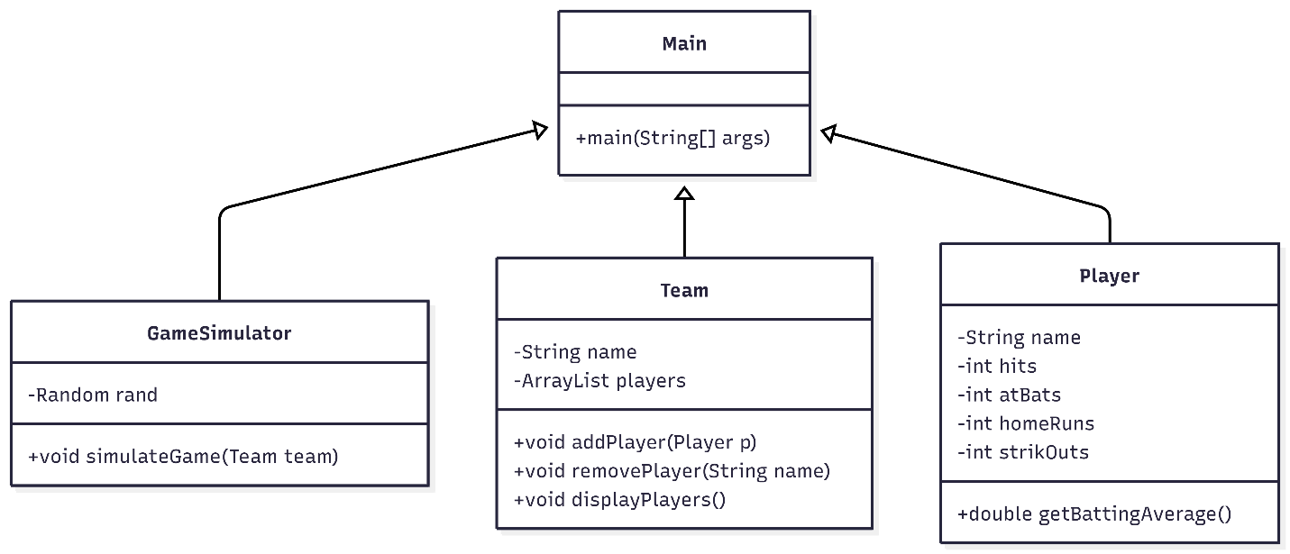

Use of OOP Paradigms –
Encapsulation: The Player class stores stats like hits, at-bats, and home runs as attributes. Methods like getBattingAverage() are used to access calculated data instead of exposing raw values
Abstraction: The GameSimulator class hides the logic of how a game is simulated. The user only needs to call simulateGame() without knowing how stats are calculated.
Inheritance: This can be incorporated by adding a base class such as Person and extending it with the Player class to add code reuse.
Polymorphism: This is demonstrated by using the overriding method by customizing the toString() method in the Player class.

Technology/Language –
- This particular project can be written in any language, but I chose to write this program in Java.

